ng –version

npm update @angular/cli (-g applied for ll projects)

npm install rxjs@6 rxjs-compat@6 –save

npm install rxjs-compat@6

generate service:

ng generate service [name]

ng new angular5-example –routing

cd angular5-example

ng serve

ng generate component login

ng generate component user

ng generate component header

ng generate component footer

ng generate component login

ng generate component dashboard

ng new angular5

ng g s user

ng g class use --type=model

ng serve –open

<https://materializecss.com/getting-started.html>

Working window bgcolor change

<https://code.visualstudio.com/docs/getstarted/themes>

<https://www.tutorialspoint.com/angular2/angular2_forms.htm>

<https://medium.com/codingthesmartway-com-blog/angular-2-forms-tutorial-introduction-8686e0c2cd39>

<https://nehalist.io/working-with-models-in-angular/>

**cmd --already port in use**

1. netstat -ano | findstr :**8080**
2. taskkill/pid 6427 /f

https://stackoverflow.com/questions/39632667/how-to-kill-a-currently-using-port-on-localhost-in-windows?utm\_medium=organic&utm\_source=google\_rich\_qa&utm\_campaign=google\_rich\_qa

Angular JS

https://stackoverflow.com/questions/31316339/how-to-solve-maven-2-6-resource-plugin-dependency

Angular Template

<html ng-app>

<!-- Body tag augmented with ngController directive -->

<body ng-controller="MyController">

<input ng-model="foo" value="bar">

<!-- Button tag with ng-click directive, and

string expression 'buttonText'

wrapped in "{{ }}" markup -->

<button ng-click="changeFoo()">{{buttonText}}</button>

<script src="angular.js">

</body>

</html>

Example 1

<http://tutorialbasics.blogspot.in/2015/10/simple-angularjs-application-in-eclispe.html>

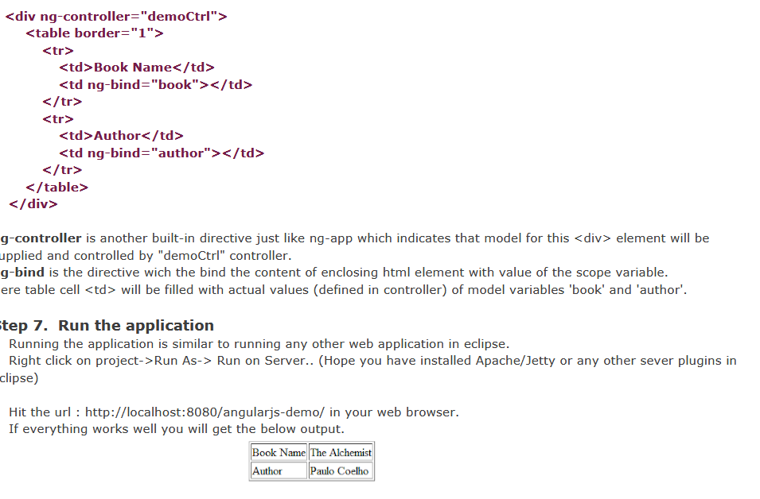

1.<div ng-controller="**MyController**">

Your name:

<input type="text" ng-model="username">

<button **ng-click='sayHello()'**>greet</button>

<hr>

{{greeting}}

</div>

Script.js

angular.module('scopeExample', [])

.controller('**MyController'**, ['$scope', function($scope) {

$scope.username = 'World';

**$scope.sayHello = function() {**

**$scope.greeting = 'Hello ' + $scope.username + '!';**

**};**

}]);

**Reverse Text No filter |Upper case:**

<div ng-controller="Controller">

<input ng-model="greeting" type="text"><br>

No filter: {{greeting}}<br>

Reverse: {{greeting|reverse}}<br>

Reverse + uppercase: {{greeting|reverse:true}}<br>

</div>

Script.js

angular.module('myReverseModule', [])

.filter('reverse', function() {

return function(input, uppercase) {

input = input || '';

var out = "";

for (var i = 0; i < input.length; i++) {

out = input.charAt(i) + out;

}

// conditional based on optional argument

if (uppercase) {

out = out.toUpperCase();

}

return out;

};

})

.controller('Controller', ['$scope', function($scope) {

$scope.greeting = 'hello';

}]);

<https://code.angularjs.org/1.2.32/docs/guide/directive>

External event ->DOM Handling

80% -of code DOM element –view,process

Data binding –reads frm model generate view

Will not reflect in model

View & model continously updates

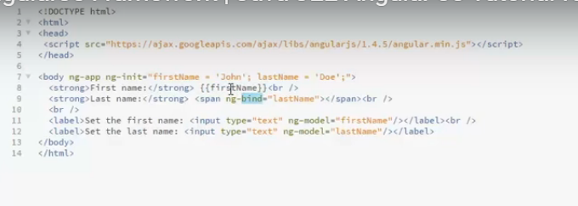

Two way data binding in Angular js The above Example shows that If I change any value in text box automatically changed in o/p also Two-way binding – Angular.js keeps the data and presentation layer in sync. Now you don't need to write additional JavaScript code to keep the data in your HTML code and your data later in sync. Angular.js will automatically do this for you. You just need to specify which control is bound to which part of your model.

<!DOCTYPE html>

<html><head>

</head><body ng-app ng-init=”fname=’John’;lname=’Doe’;”>

<strong>First name:</strong>{{fname}}<br/>

<strong>Lastname:<strong><span ng-bind=”lname”></span><br/>

<br/>

<label>Set the first name :<input type =”text” ng-model=”fname”/></label><br/>

<label>Set the last name :<input type =”text” ng-model=”lname”/></label><br/>

<body>

<html>

Ex2

<div ng-app ng-init="qty=1;cost=2">

<b>Invoice:</b>

<div>

Quantity: <input type="number" min="0" ng-model="qty">

</div>

<div>

Costs: <input type="number" min="0" ng-model="cost">

</div>

<div>

<b>Total:</b> {{qty \* cost | currency}}

</div>

</div>

<http://www.j2eebrain.com/java-J2ee-angularjs-event-handling-introduction.html>

ex3 : https://www.guru99.com/angularjs-controller.html

<!DOCTYPE html>

<html lang="en">

<head>

<meta chrset="UTF 8">

<title>Guru99</title>

</head>

<body ng-app="app">

<h1 ng-controller="HelloWorldCtrl">{{message}}</h1>

<script src="https://code.angularjs.org/1.6.9/angular.js"></script>

<script>

angular.module("app", []).controller("HelloWorldCtrl", function($scope) {

$scope.message="Hello World"

} )

</script>

</body>

</html>

Angularjs +j2 ee

<https://www.youtube.com/watch?v=HhroyiYFmjc>

https://www.youtube.com/watch?v=2B3qL7XtKnE

http://www.tech-recipes.com/rx/39279/create-a-new-maven-project-in-eclipse/

<https://www.tutorialspoint.com/angular4/angular4_environment_setup.htm>

https://www.concretepage.com/angular/

Angularjs +j2 ee

https://www.youtube.com/watch?v=HhroyiYFmjc

https://www.youtube.com/watch?v=2B3qL7XtKnE

netbeans + angular js +j2ee

<https://www.youtube.com/watch?v=2B3qL7XtKnE>

<https://rishabh.io/misc/angular-4-project-structure.html>

Type script plugin for netbeans

https://github.com/Everlaw/nbts/releases

<http://javasampleapproach.com/spring-framework/spring-mvc/angular-4-spring-jpa-mysql-example-angular-4-http-client-spring-boot-restapi-server#12_Angular_4_Client>

http://javasampleapproach.com/spring-framework/spring-boot/use-angular-httpclient-post-put-delete-data-springboot-rest-apis-angular-4

npm config help

https://www.c-sharpcorner.com/article/how-to-use-npm-install-the-command-behind-corporate-proxy-server/

set path in environment variable

C:\Program Files\nodejs\

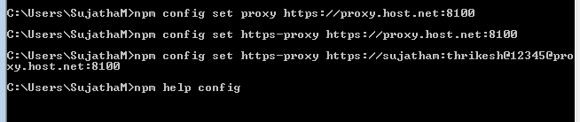

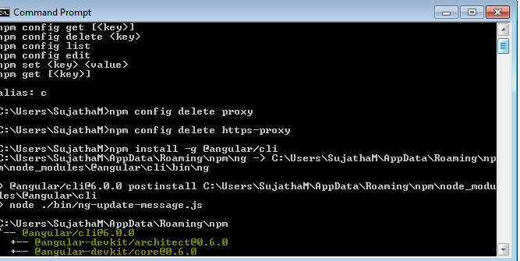

The above 2 screen reference not required .for npm config delete …command

Run Project

>>ng serv

>

>Create New Project

>>ng new project

Ex:

1.ng new samp

2.cd samp

3.samp>ng serve

>

>Create new Component

>>ng g c component\_name

>

>Create Service

>>ng g service servicename

>

>Create Pipe

>>ng g pipe pipename

>

>Change Port Number

>>ng serve --port 4100

>Set Proxy for Proxy issues

>>npm config set proxy <http://172.16.0.10:8100>

Received Error –While creating app

ng new sds

[ .................] - fetchMetadata: sill fetchPackageMetaData error for codel

npm config set proxy <http://172.16.0.10:8100>

c:\Users\SujathaM\sds>cd..

C:\Users\SujathaM>ng -v

ng serve --port 4100

Update Angular in CMD:

npm install -g @angular/cli@latest

To check angular version

ng –version

npm update -g @angular/cli

<https://dzone.com/articles/building-angular5-application-step-by-step>

ng new angular5-example –routing

cd angular5-example

ng serve

ng generate component login

ng generate component user

C:\pro1\angular5-exam\src\app>ng g module app

C:\pro1\angular5-exam\src\app\user>ng g service user

Create routing command:

ng generate module app-routing

<https://www.tutorialspoint.com/angular4/angular4_quick_guide.htm>

<https://code.visualstudio.com/docs?start=true>

<https://code.visualstudio.com/updates/v1_23>

http://localhost:4300/

<https://code.visualstudio.com/docs/java/java-spring-boot>

https://coursetro.com/posts/code/111/Using-the-Angular-5-Router-(Tutorial)

https://dzone.com/articles/building-angular5-application-step-by-step

need to refer :https://auth0.com/blog/angular2-series-forms-and-custom-validation/

<https://angular.io/tutorial/toh-pt5>

routing module example : https://www.youtube.com/watch?v=x8UR5DZcts8

https://angular.io/tutorial/toh-pt4

http://jasonwatmore.com/post/2016/12/01/angular-2-communicating-between-components-with-observable-subject

vs code open in browser

<https://www.youtube.com/watch?v=T8DrI6K8ArE>

\\172.16.5.141\d$\Users\Akilesh Kumar R\Angular 2\New folder

how to upgrade

<https://debugmode.net/2017/06/22/how-to-upgrade-to-latest-angular-cli/>

<https://www.concretepage.com/angular-2/angular-observable-example>

private userUrl="http://localhost/angular2/demo1/get\_users.php";

constructor(private http:Http){}

getUsers():Observable< Users[]>{

return this.http.get(this.userUrl).map(

(response:Response)=><Users[]> response.json());

}

Refer☹AKILESH

login(formData): any {

var headers = new Headers();

var params = "JSON="+JSON.stringify(formData);

headers.append('Content-Type','application/x-www-form-urlencoded');

return this.\_http.post(this.\_loginurl,params,{headers:headers})

.map(

(response:Response) =>response.json()

)

.do(data =>

{

if(data.status !== 0){

this.isLoggedIn= "true";

sessionStorage.setItem("isLoggedIn","true");

console.log(this.isLoggedIn);

}

}

)

.catch(this.handleerror);

}

public handleerror(error:Response){

console.error(error);

return Observable.throw(error.json().error());

}

<http://jasonwatmore.com/post/2016/09/29/angular-2-user-registration-and-login-example-tutorial>

<http://devarea.com/angular-5-services/>

<https://www.npmjs.com/package/rxjs-compat>

<https://dzone.com/articles/observables-with-the-angular-5>

<https://www.metaltoad.com/blog/angular-5-making-api-calls-httpclient-service>

https://stackoverflow.com/questions/49620090/angular-5-get-data-with-observable-and-httpclient-fetching-data-from-web-api?utm\_medium=organic&utm\_source=google\_rich\_qa&utm\_campaign=google\_rich\_qa

Using the following imports:

import {Observable} from 'rxjs/Observable';

import 'rxjs/add/observable/of';

import 'rxjs/add/operator/delay';

Try this:

let fakeResponse = [1,2,3];

let delayedObservable = Observable.of(fakeResponse).delay(5000);

delayedObservable.subscribe(data => console.log(data));

.map Error

Solved :<https://github.com/ReactiveX/rxjs/blob/master/MIGRATION.md>

npm install rxjs@6 rxjs-compat@6 –save

Observable error recovery

soln :

npm install rxjs-compat

npm install request-options

import {RequestOption} from ‘@angular/http’

https://v2.angular.io/docs/ts/latest/api/http/index/RequestOptions-class.html

import 'rxjs/add/operator/map';

import 'rxjs/add/operator/catch';

To create dist in angular project

**ng build –prod**

Angular in netbean steps

https://www.tutorialjinni.com/angular-2-netbeans-8.2-typescript-hello-world-example.html

<http://mydevgeek.com/angular-4-crud-application-with-spring-boot-rest-service-part-2/>

<http://websystique.com/springmvc/spring-mvc-requestbody-responsebody-example/>

<http://jasonwatmore.com/post/2016/09/29/angular-2-user-registration-and-login-example-tutorial>

https://www.concretepage.com/spring-boot/spring-boot-rest-angular-2-jpa-hibernate-mysql-crud-example

Sample 1:

Asset\Json\moreevents.json

[{

"EventID": 1,

"EventTitle": "AMCAT: Employement Assessment Test",

"EventDesc": "According to my AMCAT exam score conducted on 25th Aug 2014 I am employable for the following profiles IT Industry - Associate (ITeS and Business Process Outsourcing), Software Engineer – IT Services, Associate (IT Operations) and Business Functions – Sales and Business Development Executive, Customer Service Executive.",

"EventStartDate":"08-25-2014",

"EventEndDate":"08-25-2014",

"EventOrganizer": "AMCAT",

"EventImageUrl": "assets/images/event/5.jpg",

"EventContactNo":987654321

},

{

"EventID": 2,

"EventTitle": "AMCAT: Employement Assessment Test",

"EventDesc": "According to my AMCAT exam score conducted on 4th Feb 2014 I am employable for he following profiles IT Industry - Associate (ITeS and Business Process Outsourcing)",

"EventStartDate":"4-02-2014",

"EventEndDate":"4-02-2014",

"EventOrganizer": "AMCAT",

"EventImageUrl": "assets/images/event/5.jpg",

"EventContactNo":987654321

},

{

"EventID": 3,

"EventTitle": "CYBERONS’13",

"EventDesc": "Won third prize in software contest competition.",

"EventStartDate":"05-04-2013",

"EventEndDate":"05-04-2013",

"EventOrganizer": "Anja College",

"EventImageUrl": "assets/images/event/5.jpg",

"EventContactNo":987654321

},

{

"EventID": 4,

"EventTitle": "TECKTRA’12",

"EventDesc": "Won first prize in software contest competition.",

"EventStartDate":"12-02-2014",

"EventEndDate":"12-02-2014",

"EventOrganizer": "Devanga Arts & Science College",

"EventImageUrl": "assets/images/event/5.jpg",

"EventContactNo":987654321

},

{

"EventID": 6,

"EventTitle": "ZESTA’11",

"EventDesc": "Won third prize in software contest competition.",

"EventStartDate":"11-02-2012",

"EventEndDate":"11-02-2012",

"EventOrganizer": "S.S. Duraisamy Nadar College",

"EventImageUrl": "assets/images/event/5.jpg",

"EventContactNo":987654321

},

{

"EventID": 7,

"EventTitle": "Building On Enterprise Public Cloud – Using Amazon",

"EventDesc": "Has participated in the workshop on Building On Enterprise Public Cloud – Using Amazon EC2",

"EventStartDate":"09-10-2013",

"EventEndDate":"09-10-2013",

"EventOrganizer": "KLN College of Engineering",

"EventImageUrl": "assets/images/event/5.jpg",

"EventContactNo":987654321

},

{

"EventID": 8,

"EventTitle": "Prepartory Examination",

"EventDesc": "Won first Class in state level PREPARATORY EXAMINATION",

"EventStartDate":"10-09-2010",

"EventEndDate":"10-09-2010",

"EventOrganizer": "Chennai Science Forum",

"EventImageUrl": "assets/images/event/5.jpg",

"EventContactNo":987654321

}

]

Moreevents.component.html

<div class="container text-center min-height" >

<div class ="col-sm-12">

<div class="rank\_head\_section">

<h3 class="rank\_header">{{ 'achievementslang.listof' }} <span>{{ 'achievementslang.achievements' }}</span></h3>

</div>

<!--

Enable HTTP service from API Search Will Work

<div class ="col-sm-3 pull-right">

<div class ="input-group">

<input type ="text" name="searchFor" placeholder ="Search by Event" class="form-control" #searchFor value="{{terms}}">

<span class="input-group-addon cursor" (click)="search(searchFor.value)"><i class="glyphicon glyphicon-search"></i></span>

</div>

</div>

-->

<table class="table table-hover table-responsive " style="min-height:450px">

<thead>

<tr>

<th class="text-center">#</th>

<th class="text-center">{{ 'achievementslang.event' }}</th>

<th class="text-center">{{ 'achievementslang.description' }}</th>

<th class="text-center">{{ 'achievementslang.eventdate' }}</th>

<th class="text-center">{{ 'achievementslang.organizer' }}</th>

<!--<th class="text-center">End Date</th>-->

</tr>

</thead>

<tbody>

<tr class="cursor-pointer" \*ngFor = 'let lst of eventData | slice:start:end; let i = index' (click)="openModal(template,lst.EventTitle,lst.EventDesc,lst.EventImageUrl)">

<th scope="row" class="col-sm-1 text-center">{{serialNoCal(i, currentPage, itemsPerPage)}}</th>

<td class="col-sm-2 text-center">{{lst.EventTitle}}</td>

<td class="col-sm-5 text-left">{{lst.EventDesc}}</td>

<td class="col-sm-2 text-center">{{lst.EventStartDate}}</td>

<td class="col-sm-3 text-center">{{lst.EventOrganizer}}</td>

<!--<td class="text-left">{{lst.EventEndDate}}</td>-->

</tr>

<tr \*ngIf="emptyData">

<td colspan="5">No Data Found !</td>

</tr>

</tbody>

</table>

<!-- Pagination Code Starts Here -->

<!-- <div class="row">

<div class="col-xs-12 col-12" \*ngIf="totalItems">

<pagination [itemsPerPage]="itemsPerPage" [totalItems]="totalItems" [maxSize]="maxSize" class="pagination-sm" [boundaryLinks]="true" [rotate]="false" (numPages)="numPages = $event" (pageChanged)="pageChanged($event)"></pagination>

</div>

</div>-->

</div>

</div>

moreevents.component.ts

import { Component, TemplateRef, OnInit} from '@angular/core';

import { EventData } from '../moreevents/moreevents';

import { MoreeventsService } from '../moreevents/moreevents.service';

import { Http , Response } from '@angular/http';

import { Observable } from 'rxjs/Observable';

import { SlicePipe } from '@angular/common';

import 'rxjs/add/operator/map';

@Component({

selector: 'app-moreevents',

templateUrl: './moreevents.component.html',

styleUrls: ['./moreevents.component.css'],

providers: [MoreeventsService]

})

export class MoreeventsComponent implements OnInit {

eventData: EventData[];

/\* eventSliceData: EventData[]; \*/

totalItems = 0;

currentPage = 1;

smallnumPages = 0;

itemsPerPage = 5;

start = 0;

end = 0;

serialNo = 0;

modalTitle="";

modalDesc="";

modalImageUrl ="";

terms ="";

emptyData=false;

constructor(private \_eventData: MoreeventsService) {

}

pageChanged(event: any): void {

/\* this.\_eventData.geteventdata(event.page,event.itemsPerPage)

.subscribe(eventData =>

{

this.eventData = eventData;

this.totalItems = eventData.length;

}

); \*/

this.start = (event.page - 1) \* event.itemsPerPage;

this.end = this.start + event.itemsPerPage;

this.currentPage = event.page;

/\* this.eventSliceData = this.eventData.slice(this.start,this.end); \*/

}

serialNoCal (i, currentPage, itemsPerPage) {

return this.serialNo = (i + 1) + ( (currentPage - 1) \* itemsPerPage );

}

ngOnInit() {

/\* this.\_eventData.geteventdata(0,10)

.subscribe(eventData =>

{

this.eventData = eventData;

this.totalItems = eventData.length;

}

); \*/

this.\_eventData.geteventdata()

.subscribe(eventData =>

{

this.eventData = eventData;

this.totalItems = eventData.length;

if(this.totalItems){

this.start = (this.currentPage - 1) \* this.itemsPerPage;

this.end = this.start + this.itemsPerPage;

/\* this.eventSliceData = this.eventData.slice(this.start,this.end); \*/

}

}

);

}

search(terms){

this.terms = terms;

if(!(this.terms == "")){

this.\_eventData.searchevent(this.terms)

.subscribe(eventData =>

{

this.eventData = eventData;

if(eventData.length > 0){

this.emptyData = false;

}else{

this.emptyData = true;

}

this.totalItems = eventData.length;

if(this.totalItems){

this.start = (this.currentPage - 1) \* this.itemsPerPage;

this.end = this.start + this.itemsPerPage;

/\* this.eventSliceData = this.eventData.slice(this.start,this.end); \*/

}

}

);

}else{

this.\_eventData.geteventdata()

.subscribe(eventData =>

{

this.eventData = eventData;

if(eventData.length > 0){

this.emptyData = false;

}else{

this.emptyData = true;

}

this.totalItems = eventData.length;

if(this.totalItems){

this.start = (this.currentPage - 1) \* this.itemsPerPage;

this.end = this.start + this.itemsPerPage;

/\* this.eventSliceData = this.eventData.slice(this.start,this.end); \*/

}

}

);

}

}

}

Moreevent.service.ts

import { Injectable } from '@angular/core';

import { Http , Response,URLSearchParams,RequestOptions } from '@angular/http';

import { Observable } from 'rxjs/Observable';

import 'rxjs/add/operator/map';

import 'rxjs/add/operator/do';

import 'rxjs/add/operator/catch';

import { EventData } from './moreevents';

@Injectable()

export class MoreeventsService {

/\* private \_eventdataurl='http://localhost/school/events.php'; \*/

private \_eventdataurl='assets/json/moreevents.json';

constructor(private \_http: Http){ }

/\*

geteventdata(page,noofitems): Observable<EventData[]> {

let params: URLSearchParams = new URLSearchParams();

params .set('page', page);

params.set('noofitems', noofitems);

let requestOptions = new RequestOptions();

requestOptions.search = params;

return this.\_http.get(this.\_eventdataurl,requestOptions)

.map((response: Response) => <EventData[]> response.json())

//.do(data => console.log(JSON.stringify(data)))

.catch(this.handleError);

}

\*/

geteventdata(): Observable<EventData[]> {

return this.\_http.get(this.\_eventdataurl)

.map((response: Response) => <EventData[]> response.json())

//.do(data => console.log(JSON.stringify(data)))

.catch(this.handleError);

}

searchevent(EventTitle: string): Observable<EventData[]> {

return this.\_http.get(this.\_eventdataurl+"?searchfor="+EventTitle)

.map((response: Response) => <EventData[]> response.json())

//.do(data => console.log(JSON.stringify(data)))

.catch(this.handleError);

}

private handleError(error: Response) {

console.error(error);

return Observable.throw(error.json().error());

}

}

More event.ts

export interface EventData {

EventID: number;

EventTitle: string;

EventDesc: string;

EventStartDate: any;

EventEndDate: any;

EventImageUrl:string;

EventOrganizer: string;

EventContactNo: number;

}

App.routing module.ts

import { NgModule } from '@angular/core';

import { RouterModule, Routes } from '@angular/router';

import {UserComponent} from './user/user.component';

import {LoginComponent} from './login/login.component';

import {MoreeventsComponent} from './moreevents/moreevents.component';

const routes: Routes = [

{ path: 'user', component: UserComponent },

{ path: 'login', component: LoginComponent },

{path : '', component : LoginComponent},

{path : 'moreevents', component :MoreeventsComponent}

];

@NgModule({

imports: [

RouterModule.forRoot(routes)

],

exports: [

RouterModule

],

declarations: []

})

export class AppRoutingModule { }

Form design

https://appdividend.com/2017/09/25/angular-form-validation-example-tutorial/

<http://jasonwatmore.com/post/2016/09/29/angular-2-user-registration-and-login-example-tutorial>

php –login validation

<https://seegatesite.com/login-form-angular-4-tutorial-for-beginner/>

<http://jasonwatmore.com/post/2016/09/29/angular-2-user-registration-and-login-example-tutorial>

<https://angular.io/guide/forms>

angular 5 User Registration using materialisecss +asp.net:

<https://www.youtube.com/watch?v=MJncyf_veEY>

Spring boot with get/post

<http://javasampleapproach.com/frontend/angular/use-angular-httpclient-post-put-delete-data-springboot-rest-apis-angular-4>

<https://mydevgeek.com/angular-4-crud-application-with-spring-boot-rest-service-part-3/>

<http://mydevgeek.com/angular-4-crud-application-with-spring-boot-rest-service-part-1/>

<https://howtodoinjava.com/tools/eclipse/how-to-import-maven-remote-archetype-catalogs-in-eclipse/>

<http://www.javainterviewpoint.com/spring-boot-hello-world-example-eclipse/http://blog.netgloo.com/2014/05/18/very-basic-web-application-with-spring-mvc-spring-boot-and-eclipse-sts/>

<http://www.javasavvy.com/spring-4-rest-hibernate-crud-example/>

<https://www.boraji.com/spring-mvc-4-hibernate-5-restful-crud-operations-example>

[http://javasampleapproach.com/frontend/angular/use-angular-httpclient-post-put-delete-data-springboot-rest-apis-angular-4#7\_Integrate](http://javasampleapproach.com/frontend/angular/use-angular-httpclient-post-put-delete-data-springboot-rest-apis-angular-4" \l "7_Integrate_Angular_App_and_SpringBoot_Server)

[\_Angular\_App\_and\_SpringBoot\_Server](http://javasampleapproach.com/frontend/angular/use-angular-httpclient-post-put-delete-data-springboot-rest-apis-angular-4" \l "7_Integrate_Angular_App_and_SpringBoot_Server)

<http://javasampleapproach.com/frontend/angular/use-angular-httpclient-post-put-delete-data-springboot-rest-apis-angular-4>

<http://www.technicalkeeda.com/spring-tutorials/complete-spring-mvc-restful-web-services-example>

<https://www.concretepage.com/angular-2/angular-2-http-post-example>

soln :

http://javahonk.com/could-not-resolve-archetype-org-apache-maven-archetypesmaven-archetype-webapp/

Git Installed

<https://git-scm.com/download/win>

set path =”c:\program files\git\bin\”;%path%

maven proper installation guide

<https://www.youtube.com/watch?v=Jtj-0yhox5s>

Maven arche type not working in eclipse

1.Installed NetBeans

2.Adding Plug ins in net beans Tools->Plugins->download-Select Downloaded pack of plugin

<https://www.packtpub.com/mapt/book/big_data_and_business_intelligence/9781847198808/12/ch12lvl1sec53/installing-ireport-plugins-in-netbeans>

downloaded STS from

<https://spring.io/tools/sts/all>

;%M2\_HOME%\bin;

nb spring boot plugin downloaded and added in netbeans

<https://github.com/AlexFalappa/nb-springboot/releases>

http://plugins.netbeans.org/plugin/67888/nb-springboot

follow the website

<https://www.developinjava.com/article/developing-springboot-applications-with-netbeans>

Refer:Error :spring framework plugin can not be resolved

https://www.youtube.com/watch?v=-8A84DHTNHQ

In net beans spring boot project structure consist of **settings.xml add the following proxy settings and also added in c:\users\sujathaM\.m2\settings.xml**

<proxy>

<active>true</active>

<protocol>http</protocol>

<host>172.16.0.10</host>

<port>8100</port>

</proxy> -->

<plugin>

<groupId>org.springframework.boot</groupId>

<artifactId>spring-boot-maven-plugin</artifactId>

<version>2.0.2.RELEASE</version>

</plugin>

goal org.codehaus.mojo:build-helper-maven-plugin:3.0.0:attach-artifact

/\*

\* To change this license header, choose License Headers in Project Properties.

\* To change this template file, choose Tools | Templates

\* and open the template in the editor.

\*/

package com.javasampleapproach.restful.test;

import org.springframework.boot.SpringApplication;

import org.springframework.boot.autoconfigure.EnableAutoConfiguration;

import org.springframework.boot.builder.SpringApplicationBuilder;

import org.springframework.boot.web.servlet.support.SpringBootServletInitializer;

import org.springframework.context.annotation.ComponentScan;

import org.springframework.stereotype.Controller;

import org.springframework.web.bind.annotation.RequestMapping;

/\*\*

\*

\* @author sujatham

\*/

@Controller

@EnableAutoConfiguration

@ComponentScan(basePackages="com.javasampleapproach.restful.controller")

public class Test extends SpringBootServletInitializer{

public static void main(String a[]){

SpringApplication.run(Test.class,a);

}

@Override

protected SpringApplicationBuilder configure(SpringApplicationBuilder application){

return(application.sources(Test.class));

}

@RequestMapping("/")

String home(){

return "home";

}

}

<plugin>

<groupId>org.codehaus.mojo</groupId>

<artifactId>exec-maven-plugin</artifactId>

<version>1.2.1</version>

<executions>

<execution>

<goals>

<goal>java</goal>

</goals>

</execution>

</executions>

<configuration>

<mainClass>C:\apache-camel-2.11.0\examples\camel-example-smooks-

integration\src\main\java\example\Main< /mainClass>

</configuration>

</plugin>

<configuration>

<mainClass>C:\apache-camel-2.11.0\examples\camel-example-smooks-

integration\src\main\java\example\Main< /mainClass>

</configuration>

Net beans Same port no prob:soln

1. netstat -ao |find /i "listening"

We get following

TCP 0.0.0.0:7981 machinename:0 LISTENING 2428 TCP 0.0.0.0:7982 machinename:0 LISTENING 2428 TCP 0.0.0.0:8080 machinename:0 LISTENING 12704 TCP 0.0.0.0:8500 machinename:0 LISTENING 2428

i.e. Port Numbers and what Process Id they are listening to

1. Stop process running at your port number(In this case it is 8080 & Process Id is 12704)

Taskkill /F /IM 12704

Taskkill /F /IM 8204

<http://javasampleapproach.com/spring-framework/spring-boot/use-angular-http-client-fetch-data-springboot-restapi>

spring boot white label error   
<https://www.youtube.com/watch?v=sXyyyDjeOTU>

typescript editor plug in for netbeas

Tools ->plugins ->Browse the downloaded nbm file

Download file from

<https://github.com/Everlaw/nbts/releases>

Net beans + angular

<https://www.tutorialjinni.com/angular-2-netbeans-8.2-typescript-hello-world-example.html>

https://jaxenter.com/angular-2-intellij-netbeans-eclipse-128461.html

<http://developer-tutorials.blogspot.in/2016/12/setting-up-development-environment-for.html>

Note :Tried to set up common IDE But Npm install not worked

<https://stackoverflow.com/questions/32319396/cors-with-spring-boot-and-angularjs-not-working>

file used in SpringBoot webcontroller

package com.javasampleapproach.restful.controller;

import java.util.HashMap;

import java.util.List;

import java.util.Map;

import java.util.stream.Collectors;

import javax.servlet.Filter;

import javax.servlet.FilterChain;

import javax.servlet.FilterConfig;

import org.springframework.web.bind.annotation.DeleteMapping;

import org.springframework.web.bind.annotation.GetMapping;

import org.springframework.web.bind.annotation.PathVariable;

import org.springframework.web.bind.annotation.PostMapping;

import org.springframework.web.bind.annotation.PutMapping;

import org.springframework.web.bind.annotation.RequestBody;

import org.springframework.web.bind.annotation.RequestMapping;

import org.springframework.web.bind.annotation.RestController;

import javax.servlet.ServletException;

import javax.servlet.ServletRequest;

import javax.servlet.ServletResponse;

import javax.servlet.http.HttpServletRequest;

import javax.servlet.http.HttpServletResponse;

import com.javasampleapproach.restful.model.Customer;

import java.io.IOException;

import javax.servlet.Filter;

@RestController

@RequestMapping(value="/api")

public class WebController implements Filter {

private Map<Integer, Customer> customers = new HashMap<Integer, Customer>(){

{

put(1, new Customer(1, "Mary", "Taylor", 24));

put(2, new Customer(2, "Peter", "Smith", 18));

put(3, new Customer(3, "Lauren", "Taylor", 31));

}

};

@GetMapping(value="/customer")

public List<Customer> getAll(){

List<Customer> results = customers.entrySet().stream()

.map(entry ->entry.getValue())

.collect(Collectors.toList());

return results;

}

@GetMapping(value="/customer/{id}")

public Customer getCustomer(@PathVariable int id){

return customers.get(id);

}

@PostMapping(value="/customer")

public Customer postCustomer(@RequestBody Customer customer){

int id = customers.size() + 1;

customer.setId(id);

customers.put(id, customer);

return customer;

}

@PutMapping(value="/customer/{id}")

public void putCustomer(@RequestBody Customer customer, @PathVariable int id){

customers.replace(id, customer);

}

@DeleteMapping(value="/customer/{id}")

public void deleteCustomer(@PathVariable int id){

customers.remove(id);

}

@Override

public void doFilter(ServletRequest req, ServletResponse res, FilterChain chain) throws IOException, ServletException {

HttpServletRequest request = (HttpServletRequest) req;

HttpServletResponse response = (HttpServletResponse) res;

response.setHeader("Access-Control-Allow-Origin", request.getHeader("Origin"));

response.setHeader("Access-Control-Allow-Credentials", "true");

response.setHeader("Access-Control-Allow-Methods", "POST, GET, OPTIONS, DELETE");

response.setHeader("Access-Control-Max-Age", "3600");

response.setHeader("Access-Control-Allow-Headers", "Content-Type, Accept, X-Requested-With, remember-me");

chain.doFilter(req, res);

}

@Override

public void init(FilterConfig filterConfig) {

}

@Override

public void destroy() {

}

}

https://appdividend.com/2018/05/13/angular-6-smart-table-example/

Git code storing :

Create git a/c with uname n pwd

Login

click + button to add new repository with repository name

create a folder in D:\ as D:\my projects

in Git cmd

fatal: unable to access 'https://github.com/sujathaananad/sampformangularCRUD.gi

t/': Failed to connect to github.com port 443: Timed out

**Soln for above 2 line in git bash –cmd**

git config --global http.proxy <http://172.16.0.10:8100>

git init

git add folder/\*

git commit –m “

<https://help.github.com/articles/adding-an-existing-project-to-github-using-the-command-line/>

D:\Barcode new>git remote add origin <https://github.com/sujathaananad/spring-REST-API-.git>

<https://github.com/sujathaananad/spring-REST-API-.git>

D:\Barcode new>git clone https://github.com/sujathaananad/sampformangularCRUD.git

D:\my projects\ git clone <https://github.com/sujathaananad/sample-angular.git>

git clone https://github.com/sujathaananad/sample-angular.git

git add test.html

git commit -m "file commited"

git push origin master

[www.topjavatutorial.com/frameworks/spring/spring-jdbc/jdbctemplate/](http://www.topjavatutorial.com/frameworks/spring/spring-jdbc/jdbctemplate/)

<http://websystique.com/springmvc/spring-mvc-4-and-spring-security-4-integration-example/-Sample> worked

QRCODE Sample

-------------------------

ngx-qr code

ng new qrcode-app –prefix qra

npm install ngx-qrcode2 –save (without –save )

ng serve –o

<https://www.youtube.com/watch?v=4bsrqHcb-hQ>

<https://medium.com/letsboot/create-qr-codes-with-ngx-qrcode2-33bf39a65022>

Barcode scanner

----------------------

<https://www.npmjs.com/package/barcode-scanner>

<https://github.com/EddyVerbruggen/nativescript-barcodescanner/blob/master/README.md>

sample for barcode scanner

<https://github.com/goergch/angular2-qrscanner>

<https://github.com/LeonardoGraselAlmeida/NgxScannerBarcode>

barcode scanner syntax :

<https://www.npmjs.com/package/barcode-scanner>

syntax :

<https://github.com/isonet/angular-barcode-scanner/blob/master/README.md>

Quagaa Used in javascript (Useful)

<https://ourcodeworld.com/articles/read/460/how-to-create-a-live-barcode-scanner-using-the-webcam-in-javascript>

rb file + quagg+ barcode reading using : <https://www.youtube.com/watch?v=qzbHxlQAa5o>

final file : Angular-readbarcode-quagga

https://github.com/LaurentSouchet-Orange/Angular-readbarcode-quagga/blob/master/Readme.md

<https://www.npmjs.com/package/@ng-bootstrap/ng-bootstrap>

ng serve --host 172.16.5.60 --port 4200 –open

npm install @zxing/ngx-scanner@latest

<https://www.npmjs.com/package/@zxing/ngx-scanner>

ngx scanner –samp barcode

<https://stackblitz.com/edit/zxing-ngx-scanner?file=app%2Fapp.component.ts>

Angular6 –login form in ng model

Project Name -(AngularClientPostPutDelete )Angular 4 client (Visual studio code) + Spring boot angular Integration(net beans Maven Proj)

–Request Response Checked

CREATE TABLE barcode\_table(id int,barcodevalue VARCHAR(25));

insert into barcode\_table values(1,'234234234');

select \* from barcode\_table;

Example Spring Boot Angular Integration :

SpringBootAngularIntegration : to Run in Browser

<http://localhost:8080/api/customer>

ref -5/25/18-eve 7.15

<https://java2blog.com/spring-mvc-hibernate-mysql-crud-example/>

Spring Rest Ctrl + CRUD + angular 6 as client

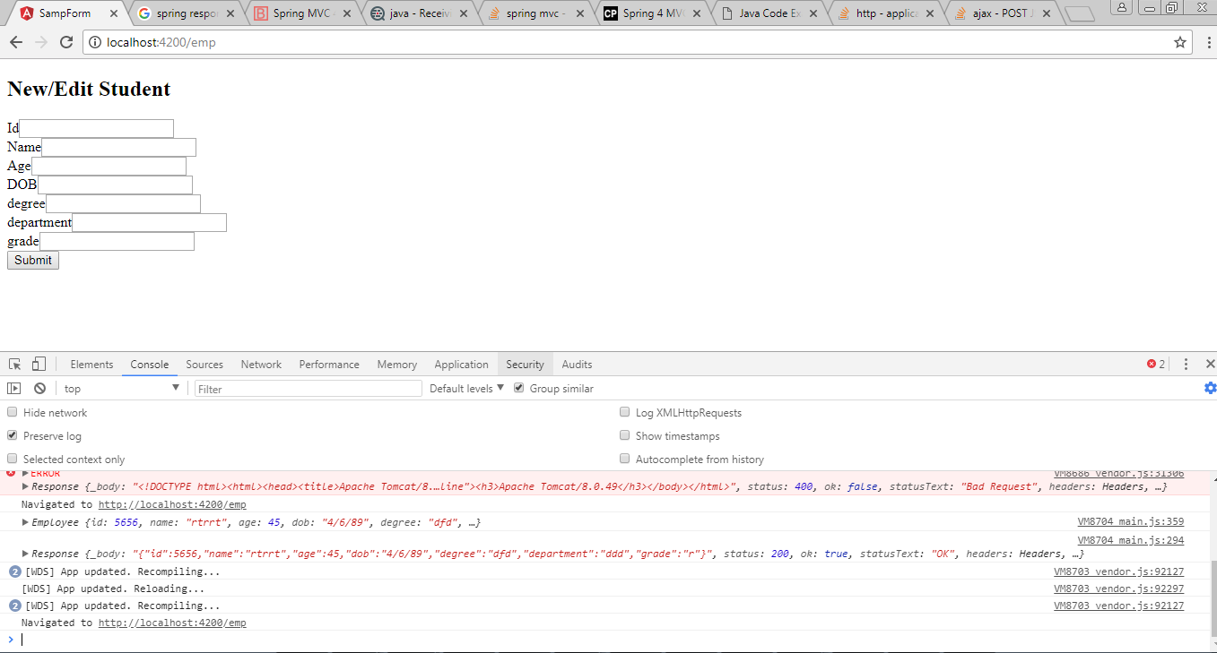

reffered

<http://javasampleapproach.com/spring-framework/spring-mvc/angular-4-spring-boot-cassandra-crud-example>

Nw response as payload

*Git clone repository*

*1.Create repository in git hub*

*2.git clone <Repository path>*

*3.Then paste all files what u want to push*

*4.c:User\Sujatha\cd repositoryfolder >git add .*

*5.git commit –m “comment”*

*6.git push –u origin master*

*https://support.codebasehq.com/articles/repositories/pushing-to-a-repository*

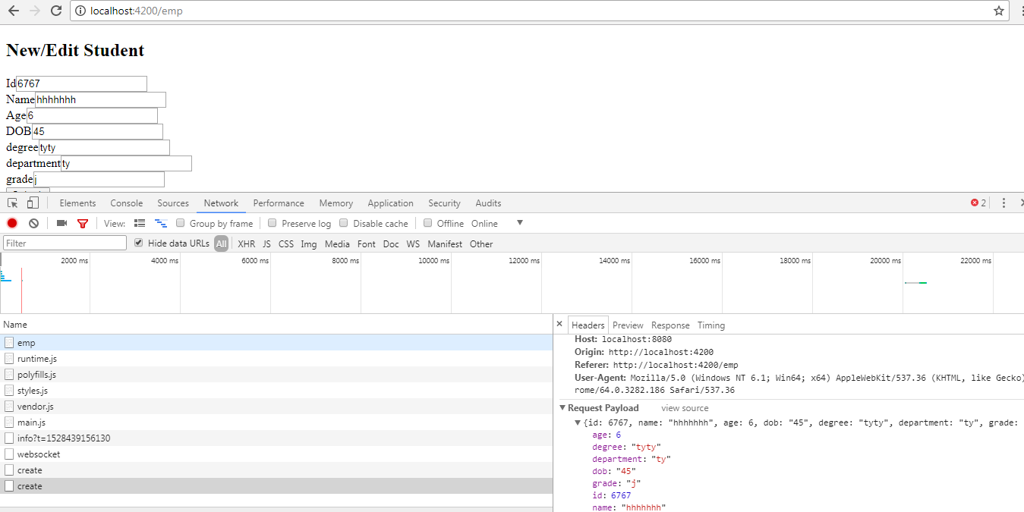

<https://www.concretepage.com/angular-2/angular-4-crud-example>

Date validation of Angular

<https://stackoverflow.com/questions/45636088/is-it-possible-to-get-and-use-angular-form-validators-result-object>

https://angular.io/guide/attribute-directives

Create a directive

ng g d directive-name

import { Directive, Input, OnChanges, SimpleChanges } from '@angular/core';

import { AbstractControl, NG\_VALIDATORS, Validator, ValidatorFn, Validators } from '@angular/forms';

/\*\* A hero's name can't match the given regular expression \*/

export function forbiddenNameValidator(nameRe: RegExp): ValidatorFn {

return (control: AbstractControl): {[key: string]: any} => {

const forbidden = nameRe.test(control.value);

return forbidden ? null : {'forbiddenName': {value: control.value}};

};

}

@Directive({

selector: '[appDate]',

providers: [{provide: NG\_VALIDATORS, useExisting: CustomdirectiveDirective, multi: true}]

})

export class CustomdirectiveDirective implements Validator {

@Input() forbiddenName: string;

validate(control: AbstractControl): {[key: string]: any} {

console.log(this.forbiddenName);

return this.forbiddenName ? forbiddenNameValidator(new RegExp(this.forbiddenName, 'i'))(control)

: null;

}

}

Component file create a constant like following

dateregEx:**RegExp**=/^\d{4}[\-.]\d{1,2}[\-.]\d{1,2}$/i; or

dateregEx:**String**=”/^\d{4}[\-.]\d{1,2}[\-.]\d{1,2}$/I”;

/^\d{4}[\/.]\d{1,2}[\/.]\d{1,2}$/i

html file :

<div *class*="form-group col-md-4">

<label>DOB</label>

<input *type*="text" *class*="form-control" *name*="dob" *id*="dob" [(*ngModel*)]="employee.dob" #*dob*="ngModel" *required* *appDate* [*forbiddenName*]="dateregEx">

<div \**ngIf*="dob.invalid && (dob.dirty || dob.touched)"

*class*="alert alert-danger">

<p \**ngIf*="dob.errors.required">

dob is required.

</p>

<p \**ngIf*="dob.errors?.forbiddenName">

only yyyy-mm-dd format;

</p>

</div>

</div>

Service hit check count

B4 subscribe

.retryWhen(

(err)=>{

return err.scan(

(retryCount) =>{

if(retryCount < 8){

retryCount += 1;

this.errmsg ="Retry Attempt #" + retryCount;

return retryCount;

}else{

throw (err);

}

},0).delay(1000);

}

)

.

<https://stackblitz.com/angular/jdgqrdondle?file=src%2Fapp%2Fheroes%2Fheroes.service.ts>

<https://www.learnrxjs.io/operators/error_handling/retrywhen.html>

github revathi

https://github.com/revathiks/my-angular/blob/master/src/app/app-routing/app-routing.module.ts

filter :Search filter

import {Pipe,PipeTransform} from '@angular/core';

@Pipe({name: 'filter'})

export class FilterPipe implements PipeTransform {

transform(value: any, searchfield: string,key: string[]): any {

console.log(key);

if (!value || !key || !searchfield) {return value;}

return value.filter( value => (value[searchfield].toLowerCase().indexOf(key) !== -1));

}

}